Events and Community Engagement Guide

Whether it’s a ribbon cutting, a stop along a green building tour, or a fun community event, there are many ways to celebrate the completion of your renewable energy project — and to share the story of its impact with the community. This guide outlines tips for planning events with ideas for a variety of ways to engage with the community.

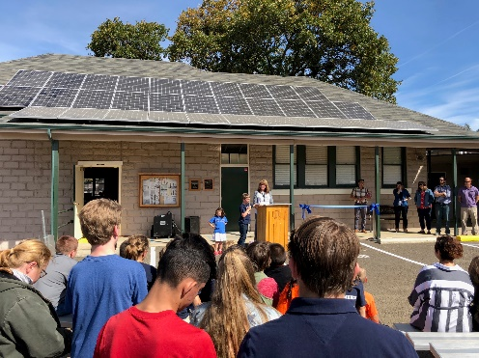
Celebration event
A popular way to commemorate the completion of a Blue Sky funded project is to hold a ribbon cutting with key project partners, stakeholders and media invited. Below is a guideline to help get you started — but look for ways to get creative and tie into your organization and its mission.

Tips for a successful ribbon cutting or other celebration:

- Invitations –
Develop a guest list and send invitations at least 3-4 weeks in advance. (Feel Free to use the media advisory language in the invitation.)

- Guests –
Invite key contacts in your organization, such as leadership, the board, and staff who worked on the project. Consider inviting elected officials such as the mayor, county commissioners, and key city council members. Community groups, members of the project team, or any other stakeholders could also be invited. Please let us know when you start to plan the event so we can be there.

- Set up –
Ideally, position your event with your new project visible or in close vicinity. Think about the backdrop and what story it tells. Plan for weather with tents, fans or heaters if needed. If your program is longer than 15 minutes, consider offering seating for guests. You may also want to serve beverages and snacks – sun tea is inexpensive and fun to make, and makes a great tie-in.

- Speakers –
Invite speakers who are key to the project to say a few words. Create a schedule that outlines the order of speakers and timing (advise speakers to keep speeches to 2-3 minutes).

- Visuals and Activities –
Include a photo opportunity with project stakeholders taking part in the ribbon cutting or other action to commemorate the event.

- Consider offering tours of the project following the ribbon cutting, or weave in renewable energy demonstrations provided by a local youth group. Look for visuals you can weave in to help attract media – look for action, color and uniqueness.

- Media and Photos
Be sure to invite local media to cover the event. See the Media Pitching Guide and template press materials to use when working with local reporters. Be sure to take lots of photos too, they can be used for many years to come.

Community engagement ideas
There are many creative ways to connect your project to the community. You can invite the community to be a part of your celebration event, or you could create a stand-alone event or engagement activity.

The key is to find creative, inexpensive ways to make an impact, educate and create a visual opportunity that works well for photos, social media posts, and media coverage. To follow are some ideas to help get you started:

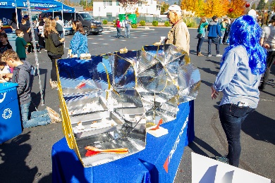
Celebrate with a “Welcome the Sun!” party
Invite families for fun activities that are focused around the sun and the clean, renewable energy it produces. Host several stations with activities such as solar car races, s’mores made with solar ovens, solar stories, and more.

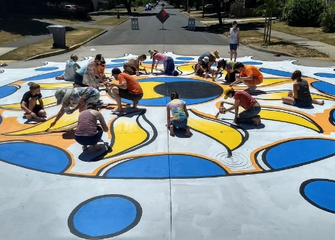
Organize a “Paint by Numbers” art installation
Ask the community to join you to help create a paint or chalk art mural in your community, such as street intersection, on a wall, or on the pavement. Hold a contest to find a design, then give everyone a role to help create.

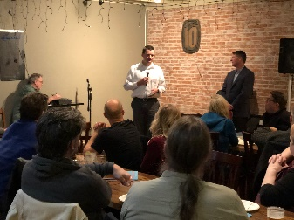
Hold a “Solar and Science” talk
Invite the public to attend an informative session lead by a local scientist or engineer to learn about solar. After, the group gets a chance to tour your facility, and see your renewable energy project in action.

To help with your celebration and/or community engagement events, be sure to check with us on items that can be provided or ordered. We have many Blue Sky materials available, including ribbons, signs, games and giveaways, tents, and more. Email us at bluesky@pacificorp.com.

